# Liste de requêtes à la BDD

## Fichier acqui_configuration.py

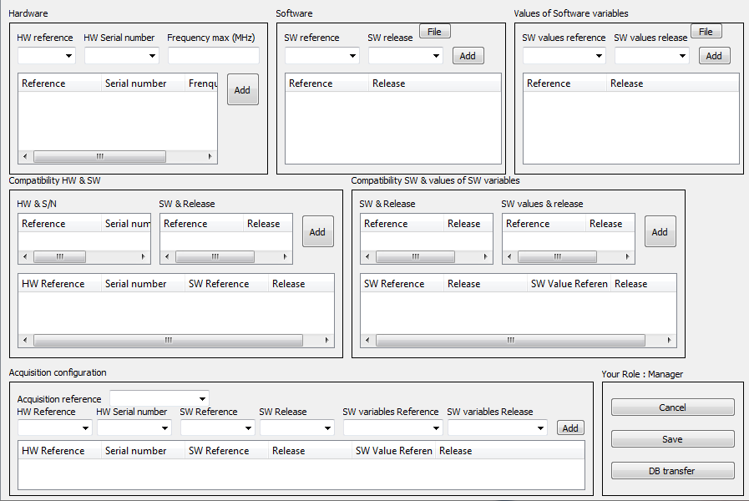

### Requête 1

#### Objet :

Pour l’utilisateur (%s), on recherche son rôle selon le cas de ses attributions

#### Sql :

sql = """SELECT ur.role, CASE WHEN ur.id_test_mean IS NOT NULL THEN CONCAT('test mean' ,'-', tm.type, '_', tm.name, '_', tm.number)

WHEN ur.id_type_coating IS NOT NULL THEN CONCAT('coating', '-', tc.ref)

WHEN ur.id_type_detergent IS NOT NULL THEN CONCAT('detergent', '-', td.ref)

WHEN ur.id_type_tank IS NOT NULL THEN CONCAT('tank', '-', tt.ref)

WHEN ur.id_type_sensor IS NOT NULL THEN CONCAT('sensor', '-',ts.ref)

WHEN ur.id_type_ejector IS NOT NULL THEN CONCAT('ejector', '-',te.ref)

WHEN ur.id_type_camera IS NOT NULL THEN CONCAT('camera', '-',tca.ref)

WHEN ur.id_type_test_point IS NOT NULL THEN CONCAT('test point', '-',ttp.ref)

WHEN ur.id_type_intrinsic_value IS NOT NULL THEN CONCAT('intrinsic value', '-',tiv.ref)

WHEN ur.insect = 'Yes' THEN CONCAT('insect', '-', ' ')

WHEN ur.acqui_system = 'Yes' THEN CONCAT('acquisition', '-', ' ') END AS object

FROM account ac

JOIN user_right ur ON ur.id_account = ac.id

LEFT JOIN test_mean tm ON tm.id = ur.id_test_mean

LEFT JOIN type_coating tc ON tc.id = ur.id_type_coating

LEFT JOIN type_detergent td ON td.id = ur.id_type_detergent

LEFT JOIN type_tank tt ON tt.id = ur.id_type_tank

LEFT JOIN type_sensor ts ON ts.id = ur.id_type_sensor

LEFT JOIN type_ejector te ON te.id = ur.id_type_ejector

LEFT JOIN type_camera tca ON tca.id = ur.id_type_camera

LEFT JOIN type_test_point ttp ON ttp.id = ur.id_type_test_point

LEFT JOIN type_intrinsic_value tiv ON tiv.id = ur.id_type_intrinsic_value

WHERE ac.uname = %s ;

"""

### Requête 2

#### Objet:

#### Sql:

sql = """SELECT CONCAT(ac.ref, '_', ac.number, ' ', to_char(ac.date, 'DD/MM/YYYY')) FROM acquisition_config ac WHERE ac.number = (SELECT MAX(number) FROM acquisition_config);"""

### Requête 3

#### Objet:

Récupérer les informations HW, SW et valeur SW pour la configuration de l’acquisition -arguments acc.ref ( ?) & acc.number ( ?)

#### Sql:

sql = """SELECT hw.ref, hw.number, hw.f_max, sw.ref, sw.release, sw_val.ref, sw_val.release

FROM hardware hw

JOIN config_on_acqui coa ON coa.id_hardware = hw.id

JOIN software sw ON coa.id_software = sw.id

JOIN software_value sw_val ON coa.id_software_value = sw_val.id

JOIN acquisition_config acc ON acc.id = coa.id_acquisition_config

WHERE acc.ref = %s AND acc.number = %s;

"""

### Requête 3

#### Objet:

Recherche de la dernière configuration d’acquisition.

#### Sql:

sql = """SELECT number, TO_CHAR(date, 'DD/MM/YYYY') FROM acquisition_config WHERE number = (SELECT MAX(number) FROM acquisition_config);"""

### Requête 4

#### Objet:

Récupérer les informations HW, SW et valeur SW pour la configuration de l’acquisition -argument acc.number ( ?)

#### Sql:

sql = """SELECT hw.ref, hw.number, hw.f_max, sw.ref, sw.release, swVal.ref, swVal.release

FROM hardware hw

JOIN config_on_acqui coa ON coa.id_hardware = hw.id

JOIN software sw ON sw.id = coa.id_software

JOIN software_value sw_val ON coa.id_software_value = sw_val.id

JOIN acquisition_config ac ON coa.id_acquisition_config = ac.id

WHERE ac.number = %s;

"""

### Requête 5

#### Objet:

Récupérer toutes les informations de la configuration d’acquisition – argument (ref & number).

#### Sql:

"""SELECT * FROM acquisition_config WHERE ref = %s AND number = %s;"""

### Requête 6

#### Objet:

Declarer une nouvelle configuration avec comme argument nom de la configuration, numéro interne & date

#### Sql:

sql = """INSERT INTO acquisition_config(ref, number, date) VALUES (%s, %s, %s);"""

### requête 7

#### objet:

écrire dans la base le contenu de la configuration

#### sql:

sql = """INSERT INTO config_on_acqui(id_hardware, id_software, id_software_val, id_acquisition_config) VALUES ((SELECT id FROM hardware WHERE ref = %s AND number = %s), (SELECT id )"""

Il ne semble pas y avoir d’execute

### Requête 8

#### Objet :

#### Sql :

insert_query = 'INSERT INTO hardware (ref, number, f_max) VALUES {}'.format(records_list_template)

### Requête 9

#### Objet :

#### Sql :

insert_query = 'INSERT INTO software (ref, release) VALUES {}'.format(records_list_template)

### Requête 10

#### Objet :

#### Sql :

insert_query = 'INSERT INTO software_value (ref, release) VALUES {}'.format(records_list_template)

### Requête 11

#### Objet :

#### Sql :

sql = """INSECT INTO hardware_software (id_hardware, id_software) VALUES ((SELECT id FROM hardware WHERE ref = %s AND number = %s), (SELECT id FROM software WHERE ref = %s AND release = %s));"""

### Requête 12

#### Objet :

#### Sql :

sql = """INSECT INTO software_value_software (id_software, id_software) VALUES ((SELECT id FROM hardware WHERE ref = %s AND number = %s), (SELECT id FROM software WHERE ref = %s AND release = %s));"""

### Requête 13

#### Objet :

#### Sql :

sql = """SELECT hw.ref, hw.number, hw.f_max

FROM hardware hw;

"""

### Requête 14

#### Objet :

#### Sql :

sql = """SELECT sw.ref, sw.release

FROM software sw;

"""

### Requête 15

#### Objet :

#### Sql :

sql = """SELECT sw_val.ref, sw_val.release

FROM software_value sw_val;

"""

### Requête 16

#### Objet :

#### Sql :

sql = """SELECT sw.ref, sw.release

FROM software sw

JOIN hardware_software hw_sw ON sw.id = hw_sw.id_software

JOIN hardware hw ON hw_sw.id_hardware = hw.id

WHERE hw.ref = %s AND hw.number = %s;

"""

### Requête 17

#### Objet :

Sql

sql = """SELECT sw_val.ref, sw_val.release

FROM software_value sw_val

JOIN software_value_software sw_v_sw ON sw_val.id = sw_v_sw.id_software_value

JOIN software sw ON sw_v_sw.id_hardware = sw.id

WHERE sw.ref = %s AND sw.release = %s;

"""

### Requête 18

#### Objet :

#### Sql :

sql = """SELECT hw.ref, hw.number, hw.f_max, sw.ref, sw.release, sw_val.ref, sw_val.release

FROM hardware hw

JOIN config_on_acqui coa ON coa.id_hardware = hw.id

JOIN software sw ON coa.id_software = sw.id

JOIN software_value sw_val ON coa.id_software_value = sw_val.id;

"""

### Requête

#### Objet :

#### Sql :

### Requête

#### Objet :

#### Sql :

### Requête

#### Objet :

#### Sql :

### Requête

#### Objet :

#### Sql :

### Requête

#### Objet :

#### Sql :

### Requête

#### Objet :

#### Sql :